# Section 5

**Citilink Bus Routes, Bus Stops, and Bus Shelters**

Citilink, Fort Wayne’s Public Transportation Corporation, provides fixed route and demand response public transit within the city limits of Fort Wayne and New Haven. Citilink is an independent unit of local government but works closely with public & private agencies to provide access and mobility to residents within our service area. Citilink operates eleven fixed routes and two flex/deviation routes with boarding & alighting along the public thoroughfares. Citilink also operates an origin to destination paratransit service called Access for people physically or mentally unable to access fixed route service; in compliance with Federal Transit Administration (FTA) ADA regulation.

**Facilities**

**Bus Stops:** It is Citilink policy to pick up passengers at designated bus stops along our fixed route system, as well as safe locations that are not stops. Citilink will drop off passengers in safe locations that are not stops. It is not possible to ensure that every potential boarding & alighting location is fully accessible. Drivers are trained to choose safe & accessible locations.

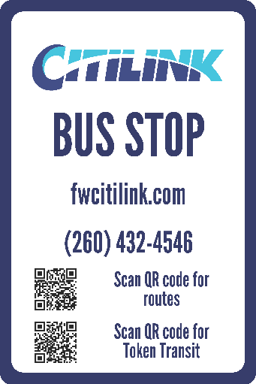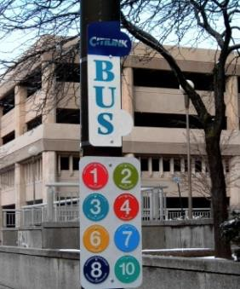**Bus Stop Signs:** Citilink bus stop signs are provided along each route to indicate the availability of bus service and the route name/number (signage is compliant with ADA requirements). Citilink has installed temporary bus stop signs at high volume bus stops that were missing signage. There are plans to install permanent signage and update the temporary signs to become permanent at all bus stops in the near future. A spreadsheet detailing the approx. 1,100 locations and passenger amenities (shelter/sidewalk/ramp) at these designated stops is attached as **Appendix 5-A**. Citilink contracts with the City of Fort Wayne Street Department to install bus stop signs; therefore, the city can help ensure that signs are posted in compliance with ADA standards. Maps detailing Citilink bus routes in relationship to existing sidewalk infrastructure is included as **Appendix 5-B**. In addition, Citilink routes, schedules, and bus stop locations can be viewed on Google Transit using the trip planner located on the Citilink website ([www.fwcitilink.com](http://www.fwcitilink.com/)).

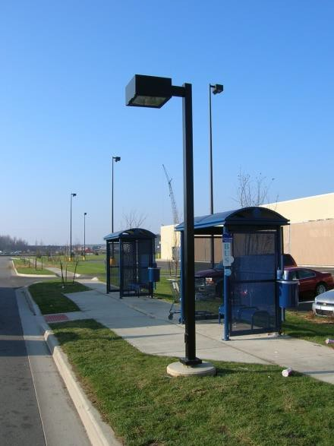**Flex route and demand response stops:** This service is provided origin to destination by advance request; these trips are delivered primarily curb to curb using existing infrastructure and lift equipped buses that provide a level platform for boarding.

**Bus Shelters:** See attached spreadsheet identifying shelters; **Appendix 5-C**. Citilink owns and operates 70 bus shelters.

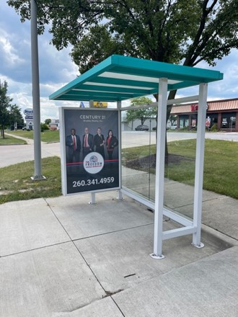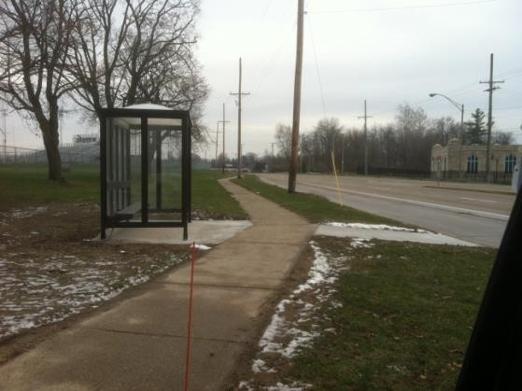

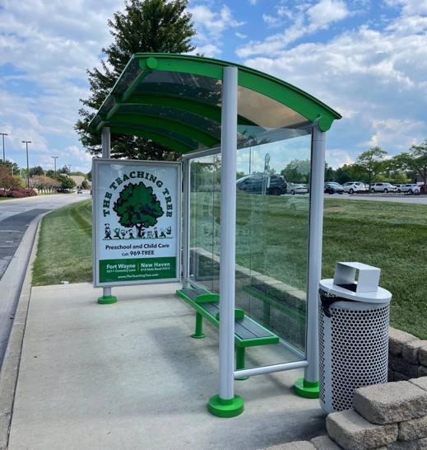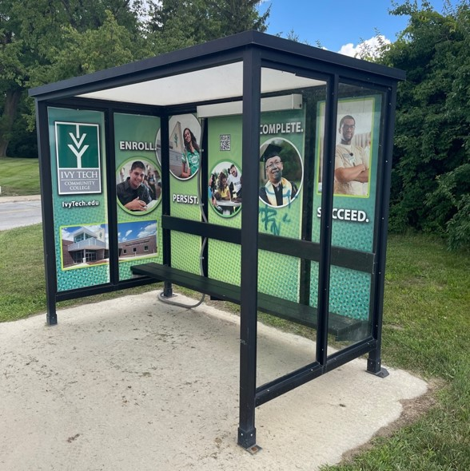

Private businesses have also placed shelters/benches at their locations with approval from the City Traffic Engineer/Right of Way.

**Transit Stations:** Citilink owns and operates two facilities. The downtown transfer station is Central Station (121 West Baker Street), which opened in the fall of 2012. Central Station is fully compliant with all ADA design requirements and standards. The Citilink administrative building is the Gionet Transit Center (801 Leesburg Road), which is a much older facility and was updated per Section 504/ADA requirements years ago. Citilink also leases a small space at the Urban League – the Hanna Creighton Neighborhood Transit Center (2135 South Hanna) which provides enhanced bus shelters. This facility was built in 2009 in compliance with ADA standards.

**Buses:** Every bus is equipped with either a ramp or lift & wheelchair securement system. The fleet has been fully compliant for over 12 years. Further, five modified minivan supervisor vehicles are equipped with a ramp & wheelchair securement system to accommodate passengers using mobility aids as needed.

**Policies/Procedures**

# Amenity Placement Procedures:

1. Solicit/receive amenity requests from passengers/drivers/general public
2. Refer request to Marketing & Development Director (Casey Claypool)
3. Check request against our current relevant amenity inventory – bus stop/bus shelter/transit facility/bus specification/pass sales outlet/marketing materials, etc
4. Determine viability of request based upon relevant factors:
   1. Availability of existing amenity in proximity to the request
   2. Resources necessary to fulfill request
   3. Resources necessary to maintain request
   4. Availability of resources
5. Accept, defer or deny request as appropriate
6. Marketing & Development Director to notify person who made the request of the status of their request
7. Attempt to complete the amenity placement process within 10 business days of receipt of request

# Shelter placement criteria:

1. Guidelines established by Citilink service standards (50 boardings/day)
2. Locations serving elderly and/or persons with disabilities
3. Community requests
4. Approved by City Traffic Engineer/Right of Way

# Passenger boarding/alighting procedures:

Bus drivers are instructed to kneel the bus &/or extend the lift or ramp when it is obviously needed and also upon request; many kneel the bus for every boarding. The ramp extends out about 50 inches to provide a stable surface for boarding and is level with the curb/sidewalk. Even where there is no sidewalk available, the low floor buses (when knelt & ramp is extended) provide slope acceptable per ADA regulations. Buses equipped with lifts provide a level boarding platform that spans the distance from ground to bus floor level. Drivers are to position the vehicle in a manner to allow for a level/stable surface and clear space for boarding the vehicle. Generally, buses are able to work around sidewalk obstructions to affect a clear passage at the entrance door. We have a form for reporting bus stop accessibility issues (**Appendix 5-D** Citilink ADA bus stop issues report form), which is processed per amenity procedures above.

# ADA/Civil Rights Policy:

Citilink has implemented appropriate policies, notification and grievance procedures as required by the ADA and Title IX per FTA regulation and guidance. These policies are incorporated into our public information materials and available via our website at the following link: <https://fwcitilink.com/about/>

Citilink receives federal funding from and reports to the Federal Transit Administration (FTA) and is in full compliance with all FTA rules and regulations as evidenced by our successful 2021 Triennial Review (available upon request).

# ADA Transition Plan Compliance:

* **Inventory** - Citilink performed a comprehensive inventory of all bus stop sign locations and installed new signage (compliant with ADA standards) in 2004. This survey has been updated utilizing a survey tool that is consistent with PROWAG standards, the compliance rating system established by the City of Fort Wayne, and tool kit resources from the Assessment of Bus Stop Accessibility and Safety provided by Easter Seals Project ACTION. We believe 15 Citilink bus shelter locations are fully compliant. This updated inventory is attached as **Appendix 5-A**.
* **Analyze** - This data will be analyzed to determine modifications needed to ensure accessibility per PROWAG guidance and the costs associated with these modifications.
* **Prioritize** - A prioritized implementation schedule will be developed based upon usage, level of modification required, collaboration with other infrastructure improvements, available resources, etc.
* **Implement** - Citilink will work with the City of Fort Wayne, City of New Haven, private businesses, community agencies, etc. to identify resources and implement bus stop improvements.

# 2025 ADA Transition Information:

Citilink has committed to various projects to move our ADA compliance forward.

Due to a grant awarded by AWS Foundation, Citilink has placed Universal Bus Shelters at the Turnstone Center for Disabilities and is in process of placing one at The League for the Blind & Disabled. These bus shelters will be fully ADA compliant. Bowen Health has purchased a Universally Accessible bus shelter for their health clinic on Goshen Rd.

In addition to the installation of new fully compliant bus shelters, we have identified over 400 bus stops out of our 1,100+ that are not fully ADA compliant. In partnership with the City of Fort Wayne, we will be identifying 10 stops a year to work towards better access.

# Citilink PROWAG/ADA Transition Plan Contact:

Casey Claypool, Marketing & Development Director

Fort Wayne Public Transportation Corporation/Citilink

801 Leesburg Road

Fort Wayne, Indiana 46808

(260)265-1021

[marketing@fwcitilink.com](mailto:marketing@fwcitilink.com)

[www.fwcitilink.com](http://www.fwcitilink.com)

Appendix 5-A: [Citilink Bus Stop Inventory](https://docs.google.com/spreadsheets/d/17Q_LRbzIse-iQYhvYfo22OG43xQJmSr9/edit?usp=sharing&ouid=112774084462503574746&rtpof=true&sd=true)

Appendix 5-B: [Map of Citilink Routes/City of Fort Wayne Sidewalks](https://drive.google.com/file/d/1SJ-JalgCuNeLKJlKgOj3x5-XXrLX7qJK/view?usp=sharing)

Appendix 5-C: [Citilink Bus Shelter Inventory](https://docs.google.com/spreadsheets/d/10tNzyU5Xs_FSH2Lg8XhDBt5QNeMpPO26/edit?usp=sharing&ouid=112774084462503574746&rtpof=true&sd=true)

Appendix 5-D: [Citilink Bus Stop Deficiency Repor](https://drive.google.com/file/d/138kw20leivz2kD8jj7ScUiV8ruYyr8W7/view?usp=sharing)t Form